**Ideation Phase**

**Define the Problem Statements**

|  |  |
| --- | --- |
| Date | 30 October 2025 |
| Team ID | NM2025TMID02969 |
| Project Name | Calculating Family Expenses Using ServiceNow |
| Maximum Marks | 2 Marks |

**Customer Problem Statement Template**

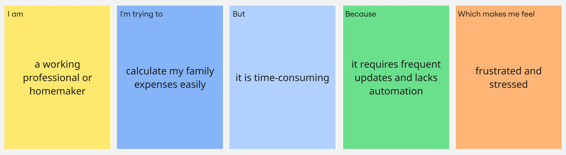

## Problem Statement Table

|  |  |  |  |  |  |
| --- | --- | --- | --- | --- | --- |
| Problem Statement (PS) | I am (Customer) | I’m trying to | But | Because | Which makes me feel |
| PS-1 | a working professional or homemaker managing my family’s monthly budget | track and record daily, weekly, and monthly family expenses easily | manual tracking using notebooks or spreadsheets is time-consuming | it requires frequent updates, calculations, and lacks automation | frustrated and stressed about losing control over my family’s spending |
| PS-2 | a user who wants to improve financial planning | analyze spending patterns and generate reports automatically | there is no centralized platform to visualize and analyze expenses | traditional methods do not provide real-time insights or automated reports | uncertain about my financial status and future savings |